Self-Learning Project Report

|  |  |  |
| --- | --- | --- |
| **No.** | **Name** | **University Id** |
| 1 | Majeed aldakheelallah |  |
| 2 | Abdulmajeed al shareif |  |
| 3 | Khalid alshiluwy |  |

programming(Python)

Group Leader Name: Abdulrahman Almyman University ID:

Section Number: 72005

Teacher Name: Mohammed ashrafuddin

Date:10/11/2019 1441/3/13

# ACKNOWLEDGEMENT

*we would like to thanks our teacher Mr. Mohammed Ashrafuddin for his guidance and support during our project work.*

# ABSTRACT

*This is our self-learning project we selected the topic “Programming(Python)”. We are going to show “Rock-Paper-* S*cissor” game in this project by using IDLE(Python).*

# Table of Contents

Contents

INTRODUCTION 6

Algorithm 6

Flowchart 6

Programming Languages 6

Features of Programming Languages 7

Simplicity 7

Naturalness 7

Efficiency 7

Compactness 7

Locality 7

Procedure 8

Step 1 8

Algorithm 8

Step 2 9

Flowchart 9

Step 3 10

Program in Python 10

Step 4: Result - Output of the Program 11

References 13

# INTRODUCTION:

**Algorithm**: An algorithm is a step by step method of solving a problem. It is commonly used for data processing, calculation and other related computer and mathematical operations. An algorithm is also used to manipulate data in various ways, such as inserting a new data item, searching for a particular item or sorting an item.

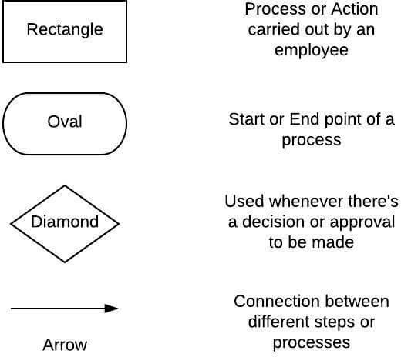

**Flowchart**: A flowchart is a formalized graphic representation of a logic sequence, work or manufacturing process, organization chart, or similar formalized structure. The purpose of a flow chart is to provide people with a common language or reference point when dealing with a project or process.

**Programming Languages:** A programming language is a formal language, which comprises a set of instructions that produce various kinds of output. Programming languages are used in computer programming to implement algorithms.

# Features of Programming Languages

**Simplicity**: A good programming language must be simple and easy to learn and use. It should provide a programmer with a clear, simple and unified set of concepts, which can be easily grasped.

**Naturalness**: A good language should be natural for the application area, for which it has been designed.

**Efficiency**: Programs written in a good programming language are efficiently translated into machine code, are efficiently executed, and acquire as little space in the memory as possible.

**Compactness**: In a good programming language, programmers should be able to express intended operations concisely.

**Locality**: A good programming language should be such that while writing a programmer concentrate almost solely on the part of the program around the statement currently being worked with.

# Procedure

## Step 1: Write an Algorithm to Add, Subtract, Multiply, Divide and find Average of two numbers.

## Algorithm:

**Step1: start.**

**Step2: Declare variables and constants**

**Step3: Input player-choice.**

**Step4: comp_choice ← random (1,3)**

**Step5: decision, if player_choice= comp_choice**

**Step6: if yes then output "draw" then stop.**

**Step7: if no then player_choice=1?**

**step7.1: if yes comp_choice = 2?**

**step7.2: if yes winner ← “player” then winner=” player”?**

**step7.3: if no winner ← “comp”**

**step8: if player_choice = 2?**

**step8.1: if yes then comp_choice=3?**

**step8.2: if yes winner ← “player” then winner=”player”?**

**step8.3: if no winner ← “comp”**

**step9: if no then player_choice = 1?**

**step9.1: if yes winner ←“player” then winner=” player”?**

**step9.2: if no winner ← “comp”**

**step10: if winner =” player”?**

**step10.1: if no then output options [comp_choice]+”beats”+options [player_choice] then end.**

**Step10.2: if if yes then output options [player_choice] +”beats”+options [comp_choice] then end then end.**

**Step11: stop**

## Step 2: Draw a flowchart for the selected algorithm.

## Flowchart:

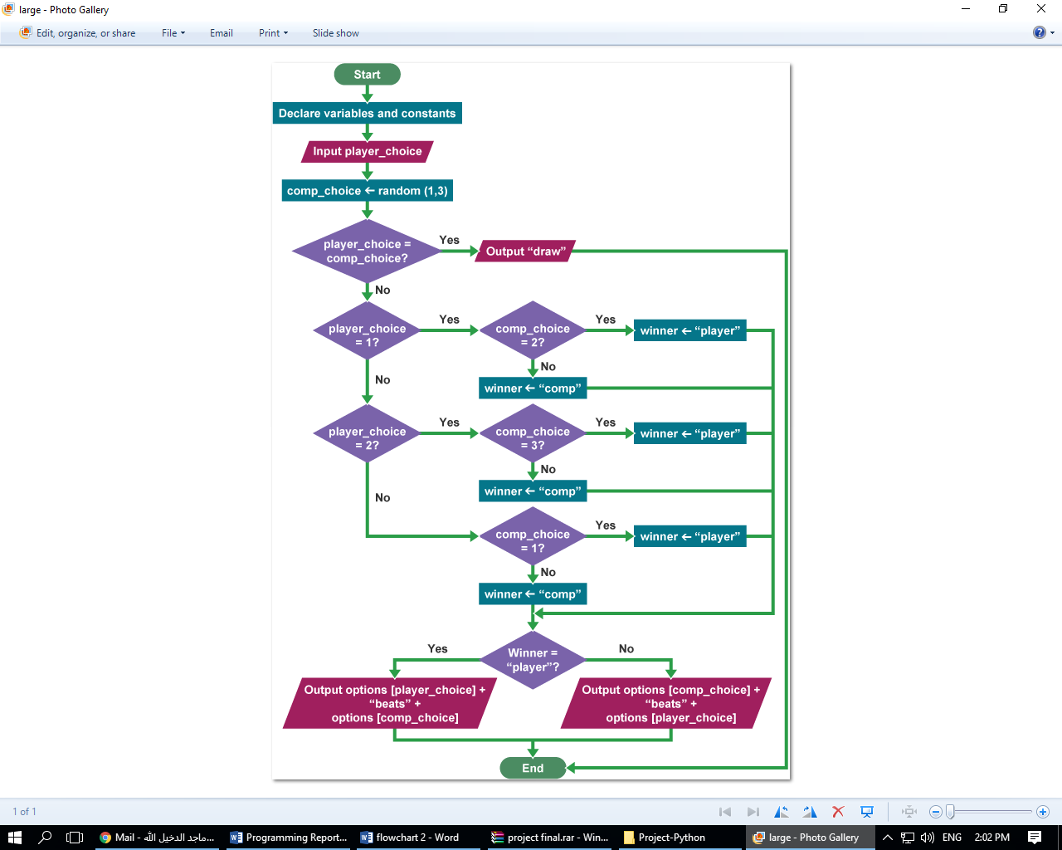

## Step 3: Write a program to get desired output based on algorithm and flowchart created.

## Program in Python:

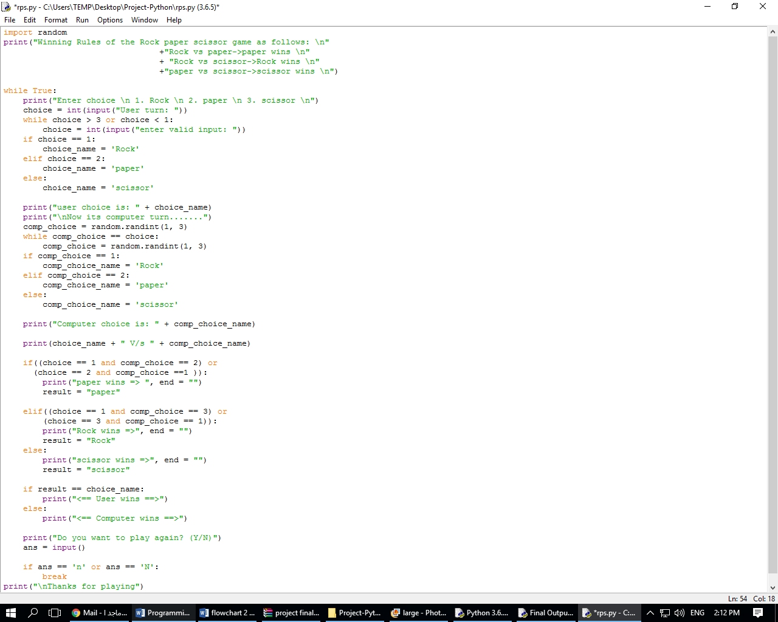

## Step 4: Result - Output of the Program.

## Save and Run the Program:

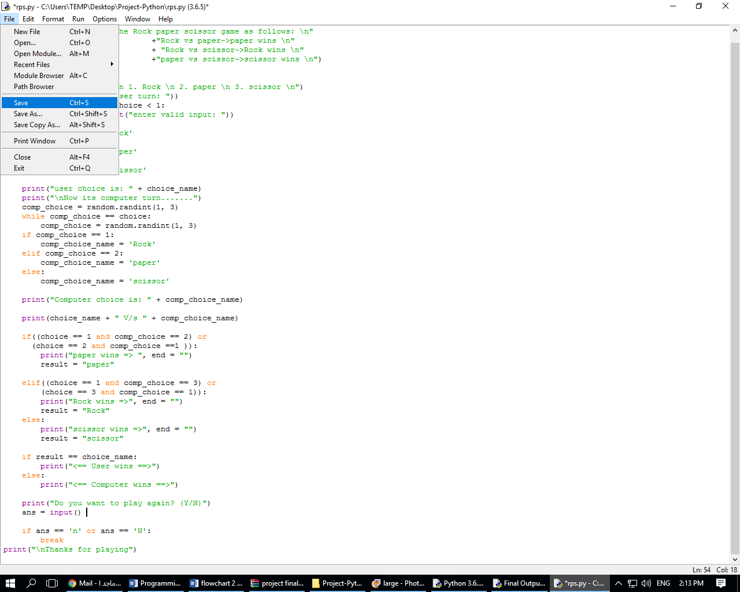

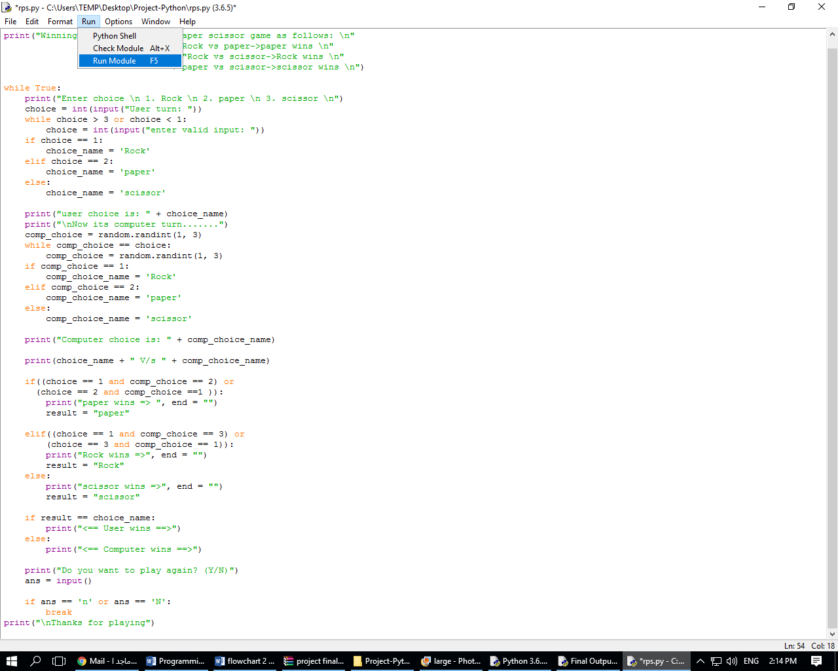

## Play with computer and choose number:

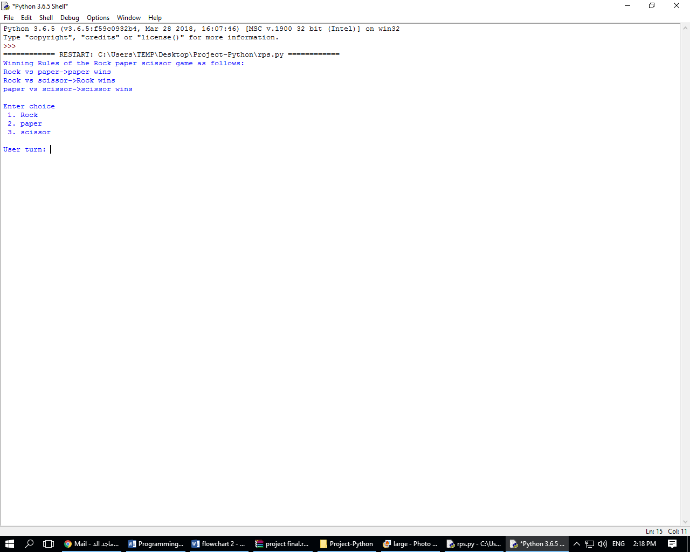

## Select Operation to get the desired output:

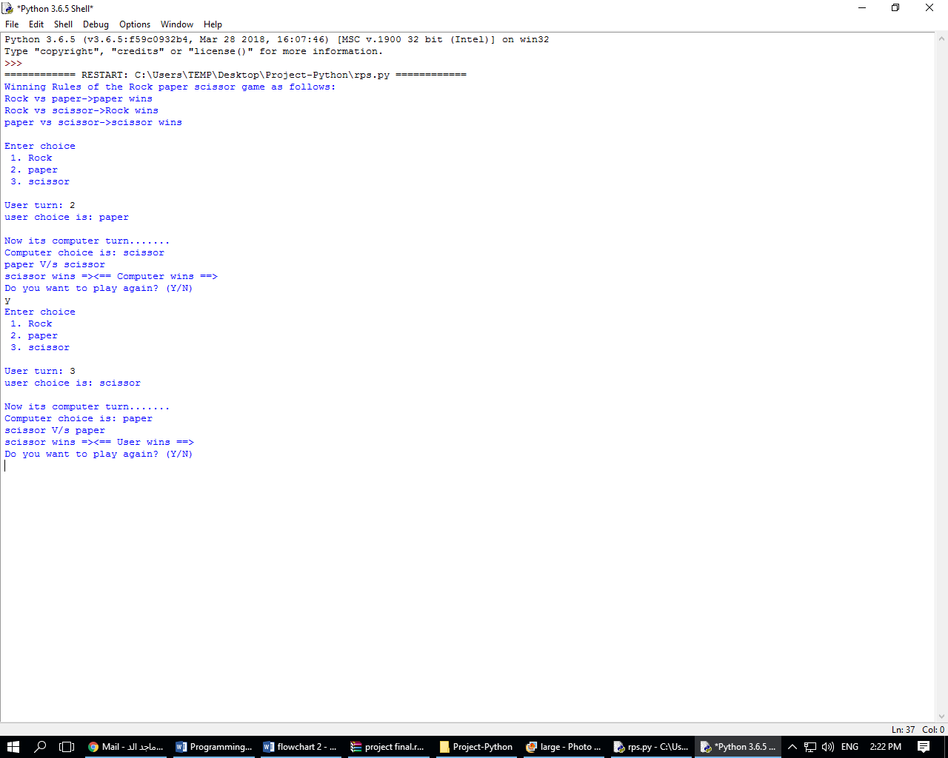

# References:

<https://www.bbc.co.uk/bitesize/guides/zjqqmsg/revision/4>

<https://thehelloworldprogram.com/python/python-game-rock-paper-scissors/>

<https://www.geeksforgeeks.org/python-program-implement-rock-paper-scissor-game/>